**Assignment 2.1**

**Task1:**

Checking whether /user/acadgild directory exists or not in HDFS

/user/acadgild directory exists in the HDFS:

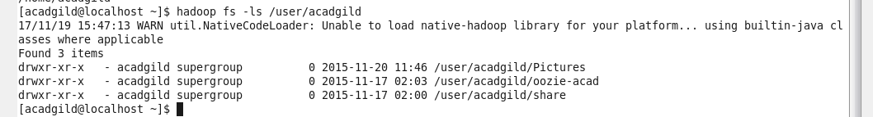

Creating a directory **‘hadoop’** under **‘/user/acadgild’**

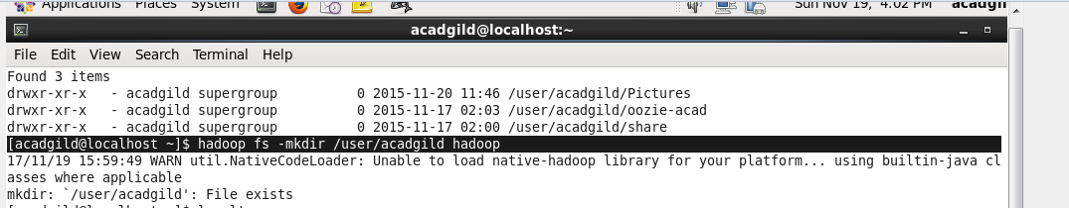

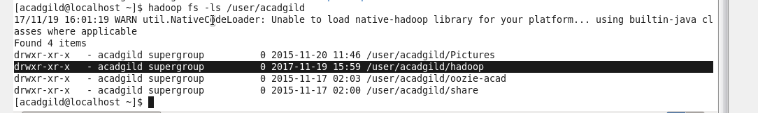

**Task2:**

Creating a file in HDFS under directory **/user/acadgild/hadoop** with the name **word-count.txt**

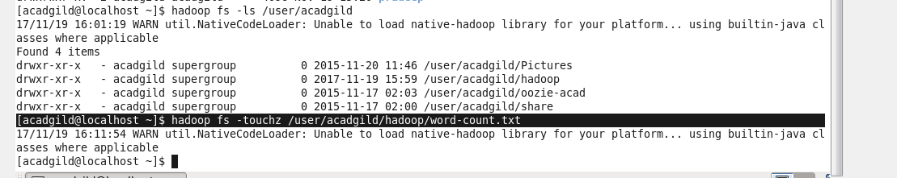

Word-count.txt file is created



**Entering text in to a word-count.txt file:**



**Size of the file is increased for word-count.txt:**



text is entered in to **word-count.txt** file:



Adding few more lines, appending text to file **‘word-count.txt’**







Now viewing all the lines (complete text) entered in to word-count.txt file:

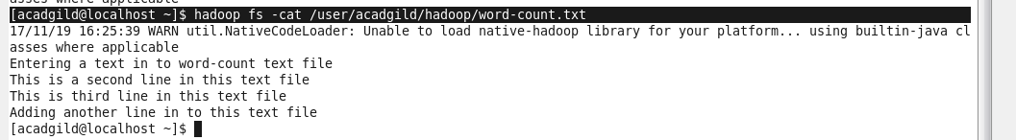

File size of word-count.txt is increased as more text is entered in to this file:

